Alex Arnold

IT 125

In class assignment 3

2/28/25

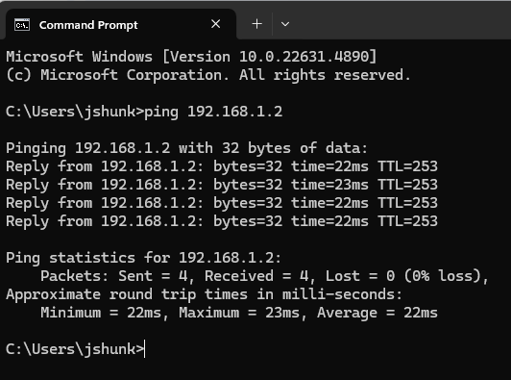

Ping form one side of the network to the switch on the opposite side of the network. Firewall issues were preventing the full ping to the machines on the other side of the network. We also had a switch that was refusing to properly send data for most of the class.